**SQL Assignment 1**

1. **What is a relational database management system (RDBMS)? What are the advantages of a database management system over a file system?**

* RDBMS is a collection of programs that enables IT teams to create, update, administer and interact relational database. It contains several tables, and each table has its primary key. Due to a collection of an organized set of tables, data can be accessed easily.
* Below points are advantages on Database management system vs File system.

Reducing Data Redundancy

Sharing of data

Data Integrity

Data Security

Privacy

Backup Recovery

Data Consistency

1. **In a database management system, explain the ACID properties.**

ACID properties in DBMS:

* A stands for Atomicity: the entire transaction takes place at once or doesn’t happen at all.
* C stands for Consistent: the database must be consistent before and after the transaction.
* I stands for Isolation: Multiple transactions occur independently without interference.
* D stands for Durability: the changes of successful transaction occurs even if the system failure occurs.

1. **Explain the concept of normalization.**

Normalization is the process of organizing data in a database. This includes creating tables and establishing relationships between those tables according to rules designed both to protect the data and to make the database more flexible by eliminating redundancy and inconsistent dependency.

1. **Explain the many types of query languages used in relational databases. DQL, DML, DCL, and DDL are some examples**.

These SQL commands are mainly categorized into four categories as:

DDL – Data Definition Language is a set of SQL commands used to create, modify, and delete database structures but not data.

DQL – Data Query Language is a component of SQL statement that allows getting data from the database and imposing order upon it. It includes the SELECT statement.

DML – Data Manipulation Language is used for manipulation of data present in the database belong to DML or Data Manipulation Language and this includes most of the SQL statements.

DCL – Data Control Language commands such as GRANT and REVOKE which mainly deal with the rights, permissions, and other controls of the database system.

TCL – Transaction Control Language is group a set of tasks into a single execution unit. Each transaction begins with a specific task and ends when all the tasks in the group successfully complete. If any of the tasks fail, the transaction fails.

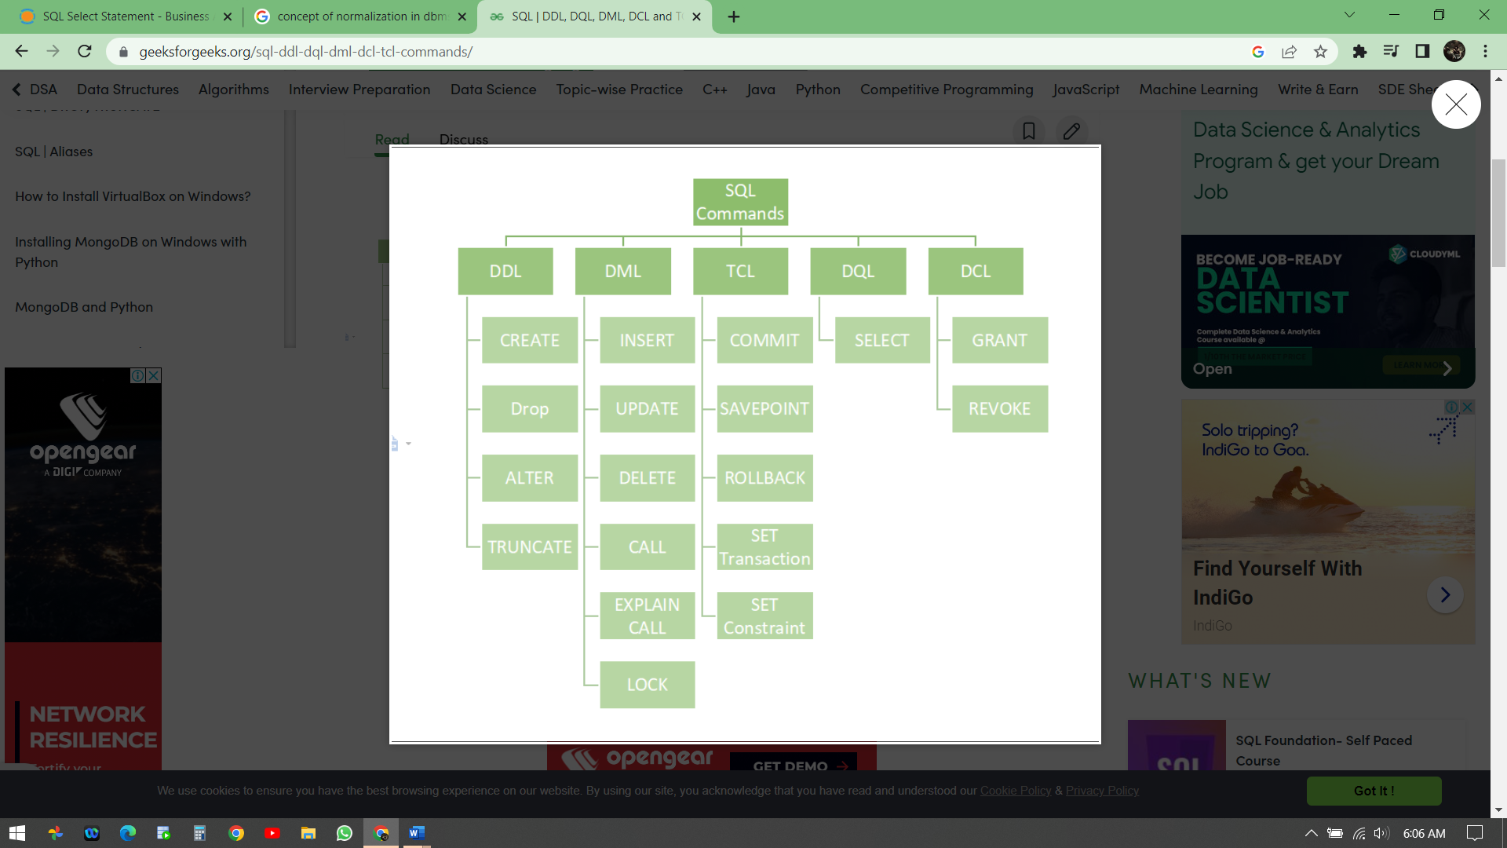

1. **What is the difference between the main key and a composite key? Give instances of how primary key and composite are used.**

Primary key is that column of the table whose every row data is uniquely identified. Every row in the table must have a primary key and no two rows can have the same primary key. Primary key value can never be null nor can be modified or updated.

Composite Key is a form of the candidate key where a set of columns will uniquely identify every row in the table.

Primary Key Syntax:

CREATE Table dbo. Customer ( CustId INT NOT NULL, CustNameVARCHAR(150), CustCode VARCHAR(20),

CustMailId VARCHAR(30), PRIMARY KEY (custId))

INSERT INTO dbo.Customer( CustId, CustName, CustCode, CustMailId)

VALUES (1, ‘Mukesh Singh’,’Cust_0056′, ‘MukeshS@gmail.com’)

VALUES (1, 'Rajesh Kumar','Cust_00545', 'RajeshKuamrgmail.com')

VALUES (NULL, 'Rajesh Kumar','Cust_00545', 'RajeshKuamr@gmail.com')

It gives an error says ‘Cannot insert the value NULL into column ‘CustId’, table ‘dbo.Customer’; column does not allow nulls. INSERT fails.’ Which means we cannot insert null values in primary key column.

Composite key Syntax:

CREATE TABLE Customer_New (

CustName VARCHAR(150) ,

Cust_bloodGroup VARCHAR(4),

CustMailId VARCHAR(30)

PRIMARY KEY(CustName, Cust_bloodGroup, CustMailId)

)

INSERT INTO dbo.Customer_New(CustName, Cust_bloodGroup, CustMailId)

VALUES

('Rocky Patel','AB+', 'RockyPatel@gmail.com'),

('Rocky Patel','AB+', 'Rocky89@gmail.com')

Here, table Customer_New have primary key on three columns Custname , Cust_bloodGroup and CustMailId so these column maintain the uniqueness of records in a table.

and for both rows have same customer and blood group combination while they have different mail id so that’s why these two row can be identified uniquely.

1. Create a table with a primary key, a column default value, and a column unique constraint in SQL.

CREATE DATABASE testDB;

USE testDB;

CREATE TABLE Persons (  
    EMP_ID int NOT NULL PRIMARY KEY,  
    Last_Name varchar(255) NOT NULL,  
    First_Name varchar(255),  
    Age int,  
    CONSTRAINT UC_Person UNIQUE (ID, LastName)  
);

SELECT * from testDB;